**VISVESVARAYA TECHNOLOGICAL UNIVERSITY**



**Jnana Sangama, Belagavi – 590018.**

WEB(18CS63) MINI PROJECT REPORT ON

“DIGITAL AGENCY WEBPAGE”

Submitted in partial fulfillment for the requirement of VI semester for the

**Degree of Bachelor of Engineering in INFORMATION SCIENCE & ENGINEERING**

For the academic year 2022-23

**SUBMITTED BY:**

**VISHAL C HALKODU[1DB20IS166]**

**Under the guidance of:**

**Mrs. DEEPIKA A B**

**Assistant Professor**

**Dept. of ISE**

**Department of Information Science and Engineering DON BOSCO INSTITUTE OF TECHNOLOGY**

**Kumbalagodu,Bengaluru-560074**

**LANGUAGES USED**

**1. HTML**

**2. CSS**

**SOURCE CODE**

**1.HTML**

<!DOCTYPE html>

<html lang="en" dir="ltr">

<head>

<meta charset="utf-8">

<title>Sample Website 2</title>

<!-- bootstrap -->

<link rel="stylesheet" href="https://maxcdn.bootstrapcdn.com/bootstrap/4.0.0/css/bootstrap.min.css" integrity="sha384-Gn5384xqQ1aoWXA+058RXPxPg6fy4IWvTNh0E263XmFcJlSAwiGgFAW/dAiS6JXm" crossorigin="anonymous">

<script src="https://code.jquery.com/jquery-3.2.1.slim.min.js" integrity="sha384-KJ3o2DKtIkvYIK3UENzmM7KCkRr/rE9/Qpg6aAZGJwFDMVNA/GpGFF93hXpG5KkN" crossorigin="anonymous"></script>

<script src="https://maxcdn.bootstrapcdn.com/bootstrap/4.0.0/js/bootstrap.min.js" integrity="sha384-JZR6Spejh4U02d8jOt6vLEHfe/JQGiRRSQQxSfFWpi1MquVdAyjUar5+76PVCmYl" crossorigin="anonymous"></script>

<!--CSS-->

<link rel="stylesheet" href="style.css">

<!-- font-awesome -->

<link href="https://stackpath.bootstrapcdn.com/font-awesome/4.7.0/css/font-awesome.min.css" rel="stylesheet" integrity="sha384-wvfXpqpZZVQGK6TAh5PVlGOfQNHSoD2xbE+QkPxCAFlNEevoEH3Sl0sibVcOQVnN" crossorigin="anonymous">

</head>

<body>

<!-- Navigation Bar -->

<section id="nav-bar">

<nav class="navbar navbar-expand-lg navbar-light">

<a class="navbar-brand" href="#"><img src="Images/logo.png" alt=""></a>

<button class="navbar-toggler" type="button" data-toggle="collapse" data-target="#navbarNav" aria-controls="navbarNav" aria-expanded="false" aria-label="Toggle navigation">

<i class="fa fa-bars"></i>

</button>

<div class="collapse navbar-collapse" id="navbarNav">

<ul class="navbar-nav ml-auto">

<li class="nav-item">

<a class="nav-link" href="#banner">HOME</a>

</li>

<li class="nav-item">

<a class="nav-link" href="#services">SERVICES</a>

</li>

<li class="nav-item">

<a class="nav-link" href="#about-us">ABOUT US</a>

</li>

<li class="nav-item">

<a class="nav-link" href="#testimonials">TESTIMONIALS</a>

</li>

<li class="nav-item">

<a class="nav-link" href="#footer">CONTACT</a>

</li>

</ul>

</div>

</nav>

</section>

<!--Banner Section -->

<section id="banner">

<div class="container">

<div class="row">

<div class="col-md-6">

<p class="promo-title"> WebFX DIGITAL AGENCY</p>

<p class="">Hi, my name is Vishal C H and I created this site using HTML5,CSS3 . I am a Sixth Semester Engineering Student.</p>

<a href="#"><img src="images/play-btn.png" class="play-btn" alt="">Watch Tutorial</a>

</div>

<div class="col-md-6 text-center">

<img class="img-fluid" src="Images/banner image.png" alt="">

</div>

</div>

</div>

<img src="Images/wave-img-1.png"class="bottom-img" alt="">

</section>

<!-- Services Section -->

<section id="services">

<div class="container text-center">

<h1 class="title" >WHAT WE DO ?</h1>

<div class="row text-center">

<div class="col-md-4 services">

<img class="service-img" src="C:\Users\vishal\Downloads\grphi.png" alt="">

<h4>Graphic Designing</h4>

<p class=""></p>

</div>

<div class="col-md-4 services">

<img class="service-img" src="Images/Online Branding.png" alt="">

<h4>Online Branding</h4>

<p class=""></p>

</div>

<div class="col-md-4 services">

<img class="service-img" src="Images/Animated Ads.jpg" alt="">

<h4>Animated Ads</h4>

<p class=""> </p>

</div>

</div>

<button type="button" class="btn btn-primary" name="button">All Services</button>

</div>

</section>

<!-- About Us Section -->

<section id="about-us">

<div class="container">

<h1 class="title text-center">WHY CHOOSE US ?</h1>

<div class="row">

<div class="col-md-6 about-us">

<p class="about-title">Why we are different ?</p>

<ul>

<li>Understand our client's business goal first</li>

<li>Believe in doing business with honesty</li>

<li>We deliver on time</li>

<li>We create a wining content strategy</li>

<li>We protect your online reputation</li>

<li>We create a wining content strategy</li>

<li>We protect your online reputation</li>

</ul>

</div>

<div class="col-md-6">

<img src="Images/about-us-img.png" class="img-fluid" alt="">

</div>

</div>

</div>

</section>

<!-- Testimonials Section -->

<section id="testimonials">

<div class="container">

<h1 class="title text-center">WHAT CLIENTS SAY</h1>

<div class="row offset-1">

<div class="col-md-5 testimonials">

<p class="">Huge is a fantastic agency that develops strategic creative and technology to deliver on our business objectives. They are truly an extension of our team that consistently delivers flawless solutions. Keep it up! ....</p>

<img src="Images/user-1.jpg" alt="">

<p class="user-details"><b>Angela</b><br> Co-Founder at xyz</p>

</div>

<div class="col-md-5 testimonials">

<p class="">We have been using WebFX for some time and continue to be impressed by their professionalism and most importantly the results we have seen..</p>

<img src="Images/user-2.jpg" alt="">

<p class="user-details"><b>Mike Tyson</b><br> Director at xyz</p>

</div>

</div>

</div>

</div>

</section>

<!-- Social Media Section -->

<section id="social-media">

<div class="container text-center">

<p>FIND US ON SOCIAL MEDIA</p>

<div class="social-icons">

<a href="#"><img src="Images/facebook-icon.png" alt="facebook-icon"></a>

<a href="#"><img src="Images/instagram-icon.png" alt="instagram-icon"></a>

<a href="#"><img src="Images/whatsapp-icon.png" alt="whatsapp-icon"></a>

<a href="#"><img src="Images/twitter-icon.png" alt="twitter-icon"></a>

<a href="#"><img src="Images/snapchat-icon.png" alt="snapchat-icon"></a>

<a href="#"><img src="Images/linkedIn-icon.png" alt="linkedIn-icon"></a>

</div>

</div>

</section>

<!-- Footer Section -->

<section id="footer">

<img src="Images/wave-img-2.png" class="footer-img" alt="">

<div class="container">

<div class="row">

<div class="col-md-4 footer-box">

<img src="Images/logo.png" alt="">

<p class="">Hi, my name is Vishal C H and I created this site using HTML5,CSS3. I am a Sixth Semester Engineering. Press the bell icon to get notifications.</p>

</div>

<div class="col-md-4 footer-box">

<p>CONTACT US</p>

<p><i class="fa fa-map-marker"></i>DBIT,Bengaluru</p>

<p><i class="fa fa-phone"></i>91+ 9019317290</p>

<p><i class="fa fa-envelope"></i>chv5240@gmail.com</p>

</div>

<div class="col-md-4 footer-box">

<p>SUSCRIBE NEWSLETTER</p>

<input class="form-control" type="email" name="" value="" placeholder="Your Email">

<button class="btn btn-primary" type="button" name="button">SUSCRIBE</button>

</div>

</div>

</div>

<hr>

<p class="copyright">Website crafted by Vishal C H </p>

</section>

</body>

</html>

**2. CSS**

*{

margin: 0 ;

padding: 0 ;

}

body{

font-family: sans-serif;

}

/* Navigation Bar */

.nav-bar{

position: sticky;

top: 0;

z-index:10;

}

.navbar{

background-image: linear-gradient(to right, #a517ba, #5f1782);

padding: 0 !important;

}

.navbar-brand img{

height:40px;+

padding-left:20px;

}

.navbar-nav li{

padding: 0 10px;

}

.navbar-nav li a{

color:#fff !important;

font-weight:600;

float: right;

text-align:right;

}

.navbar-toggler{

outline: none !important;

}

.fa-bars{

font-size: 30px !important;

color: #fff;

}

/* Banner Section */

#banner{

padding-top :5%;

color: #fff;

background-image: linear-gradient(to right, #a517ba, #5f1782);

}

.promo-title{

font-size: 40px;

font-weight: 600;

margin-top: 100px;

}

.play-btn{

width: 45px;

margin: 20px;

}

#banner a{

color: #fff;

text-decoration: none;

}

.bottom-img{

width: 100%;

}

/* Service Section */

#services{

padding: 80px 0;

}

.service-img{

width: 200px;

margin-top: 20px;

}

.services{

padding: 20px;

}

#services h4{

padding: 4px;

margin-top: 25px;

text-transform: uppercase;

}

.title::before {

content: '';

height: 5px;

width: 200px;

background-color: #7b1798;

margin-left: auto;

margin-right: auto;

display: block;

transform: translateY(63px);

}

.title::after {

content: '';

height: 10px;

width: 50px;

background-color: #7b1798;

margin-left: auto;

margin-right: auto;

margin-bottom: 40px;

display: block;

transform: translateY(8px);

}

#services .btn-primary{

padding: 8px 25px;

box-shadow: none;

border: none;

border-radius: 20px;

background-image: linear-gradient(to right, #a517ba, #5f1782);

}

/* About Us Section */

#about-us{

background-color: #f8f9fa;

padding-bottom: 50px;

padding-top: 50px;

}

.about-title{

font-size: 40px;

font-weight: 600;

margin-top: 8%;

}

#about-us ul li{

margin: 10px 0;

}

#about-us ul{

margin-left: 20px;

}

/* Testimonials Section */

#testimonials{

margin:100px 0;

}

.testimonials{

border-left: 4px solid #7b1798;

margin-top: 50px;

margin-bottom: 50px;

}

.testimonials img{

height: 60px;

width: 60px;

border-radius: 50%;

margin:0 10px;

}

.user-details{

display: inline-block;

font-size: 12px;

}

/* Social Media Section */

#social-media{

background-color: #f8f9fa;

padding: 100px 0;

}

#social-media p{

font-size: 36px;

font-weight: 600;

margin-bottom: 30px;

}

.social-icons a img{

width: 60px;

transition:0.5s;

}

.social-icons a img:hover {

transform: translateY(-10px);

}

/* footer section */

#footer{

background-image: linear-gradient(to right, #a517ba, #5f1782);

color: #fff;

}

.footer-img{

width:100%;

}

.footer-box{

padding: 20px;

}

.footer-box img{

width: 50px;

margin-bottom: 20px;

}

.footer-box .fa{

margin-right: 8px;

font-size: 25px;

height: 40px;

width: 40px;

text-align: center;

padding-top: 7px;

border-radius: 2px;

background-image: linear-gradient(to right, #a517ba, #5f1782);

}

.footer-box .form-control{

box-shadow: none !important;

border: none;

border-radius: 0;

margin-top: 25px;

max-width: 250px;

}

.footer-box .btn-primary{

box-shadow: none !important;

border: none;

border-radius: 0;

margin-top: 30px;

background-image: linear-gradient(to right, #a517ba, #5f1782);

display: block;

}

hr{

background-color: #fff;

width: 80%;

margin:auto;

}

.copyright{

margin:10px 0 0 0;

padding-bottom: 0;

text-align: center;

}

**OUTPUT SNAPSHOTS**

**HOME PAGE**

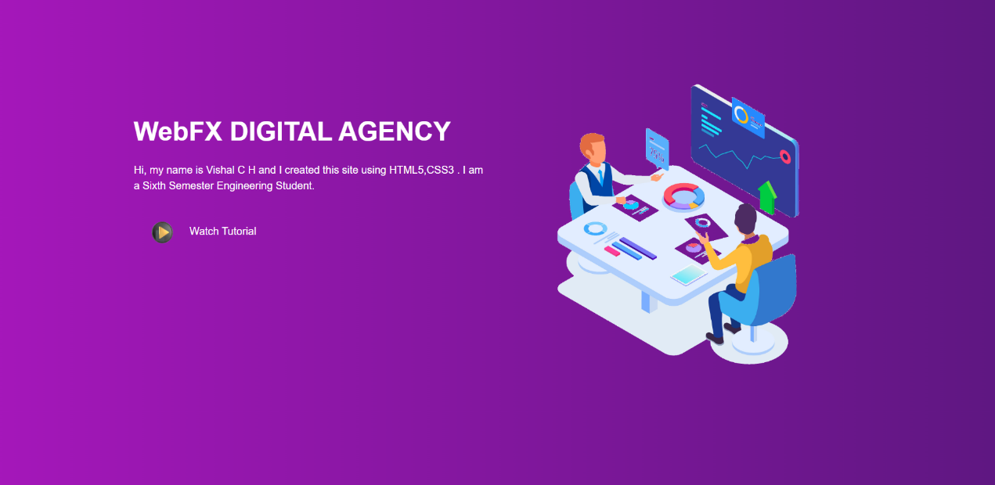

**ABOUT US PAGE**

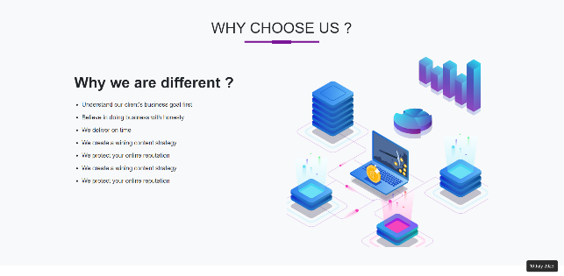

**SERVICES PAGE**

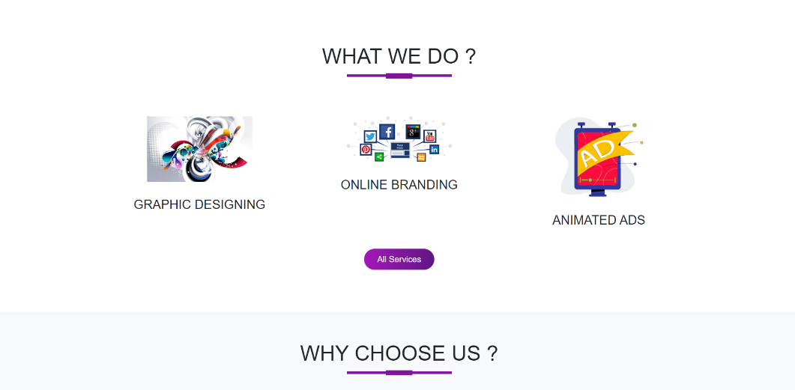

**CONTACT PAGE**

